**ISYS3401 IT Evaluation**

**Tutorial 10**

**Assessment of Scale Reliability**

Suppose the construct “Satisfaction” is measured using 4 items from 5 respondents (you can assume this is from a *sample*). The data and the correlation matrix are shown below.





**Formulae**

**Sample Variance:**

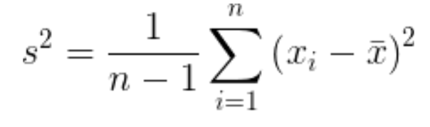

**Population Variance:**

$$σ^{2}=\frac{\sum{{\left(X-μ\right)}^{2}}}{N}=\frac{\sum{X^{2}}}{N}-μ^{2}$$

$$r=\frac{N\sum{xy-\left(\sum{x}\right)\left(\sum{y}\right)}}{\sqrt{\left[N\sum{x^{2}}-{\left(\sum{x}\right)}^{2}\right]\left[N\sum{y^{2}}-{\left(\sum{y}\right)}^{2}\right]}}$$

$$r_{xx}=\frac{2r_{hh}}{1+r_{hh}}$$

$$α=\frac{K}{K-1}\left(1-\frac{\sum_{i=1}^{K}{σ_{Yi}^{2}}}{σ_{X}^{2}}\right)$$

$$α_{standardized}=\frac{K\overline{r}}{1+\left(K-1\right)\overline{r}}$$

Using the Excel dataset you have downloaded from Canvas:

1. Use Excel to answer these questions.
2. Use the formulae to answer these questions (hopefully, you will get the same answer!).
3. If time permits, try run in SPSS (follow the slide is in the lecture), and see if you get the same answer.

Compute the following:

* 1. Average inter-item correlation
  2. Average item-to-total correlation
  3. Split-half correlation between Q1+Q3 and Q2+Q4.
  4. Split-half reliability
  5. Alpha (Unstandardised)
  6. Standardised alpha
  7. Comment on the reliability of the scale items.